Our October Visit to Prospect Point, Blue Mtn. NY, - October 2020

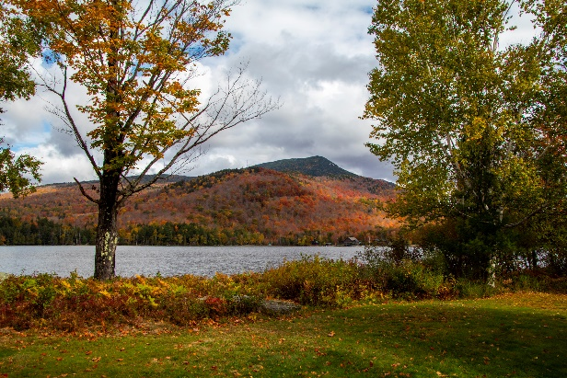This was our annual visit to [Prospect Point Cottages](http://prospectpt.com/) on Blue Mountain Lake, NY, this October. The weather forecasts were quite clear: cold, so we decided to do the trek without our kayaks.

The weather was as advertised which did give us a wonderful opportunity to enjoy the colorful Fall foilage and the local areas. The days began with our 3.8 mile morning walk around the village and down to Durant Lake. The number of deer and their comfort level with us was amazing. Then, there were the ravens! The highlights included the the local hiking around Prospect Point, the Newcomb trails, area towns, and other walking/hiking areas. A bit of quiet reading and overlooking the lake also ensued. At [Buttermilk Falls](https://fauxes.net/Sounds/Condo%20Sounds/ButtermilkFalls-ripples-October%206%202020%20124022%20PM.mp3), we shot several sequences of the roaring waters with 3-4 images with exposures running from 1/4,000 to over 1 second – crisp to silk. Be sure to check out the differences.

What a beautiful peaceful time of year to roam outside each day and see a different scene unfold. Next year is already inked in!

And for the photos, click [Prospect Point – October 2020.](https://photos.app.goo.gl/PMFJKZW3RvJEX5gb7)